1. **pwd**

**pwd command** (print working directory) writes the full pathname of the current working directory to the standard output.

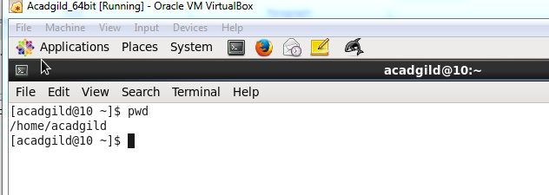

1. **vi**

Using **vi** you can insert text anywhere in the file very easily. Most of the **vi** commands move the cursor around in the file.

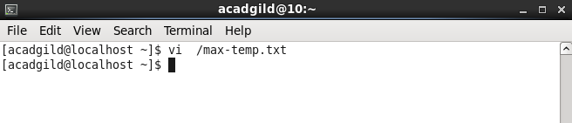

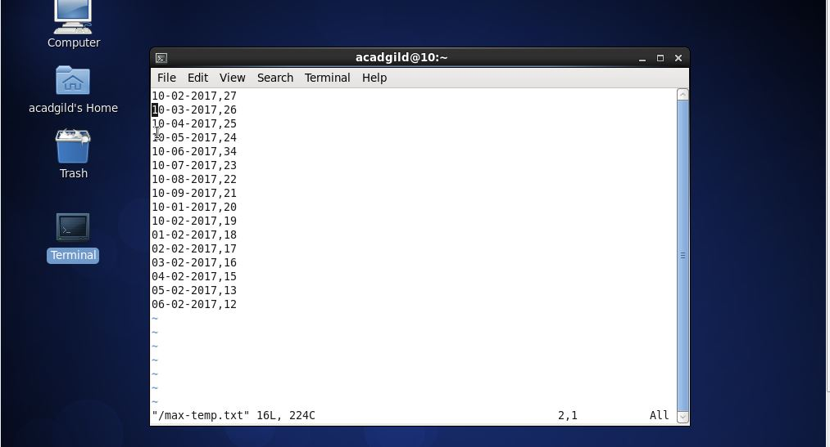

1. **touch**

The touch command is a standard program for Unix/Linux operating systems, that is used to create, change and modify timestamps of a file. Before heading up for touch command examples, please check out the following options.

Touch Command Options

1. -a, change the access time only
2. -c, if the file does not exist, do not create it
3. -d, update the access and modification times
4. -m, change the modification time only
5. -r, use the access and modification times of file
6. -t, creates a file using a specified time

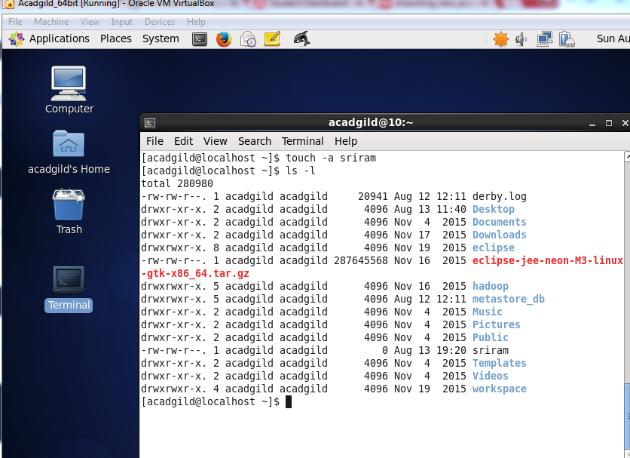

1. mkdir

The **mkdir** (make directory) **command** in the **Linux**



1. **rm**

**rm** (short for remove) is a basic **Linux command** used to remove objects such as files, directories, device nodes, symbolic links, and so on from the filesystem.

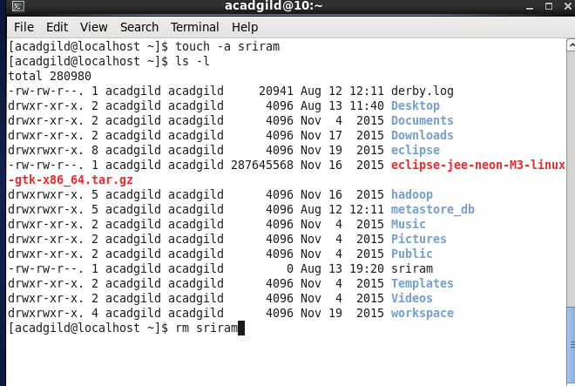

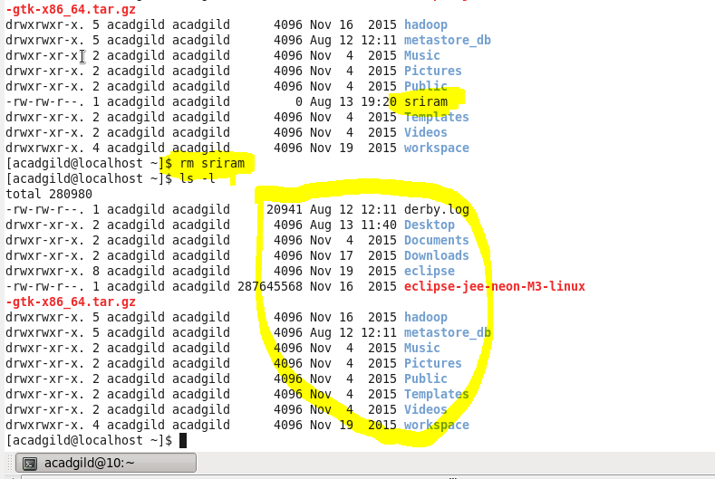

1. ls

**ls** lists the files in the current working directory.



1. echo

**echo** is one of the most commonly and widely used built-in **command** for **Linux** bash and C shells, that typically used in scripting language and batch files to display a line of text/string on standard output or a file.

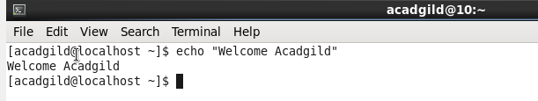

1. Cat

The cat (short for “concatenate“) command is one of the most frequently used command in Linux/Unix like operating systems. cat command allows us to create single or multiple files, view contain of file, concatenate files and redirect output in terminal or files. In this article, we are going to find out handy use of cat commands with their examples in Linux.

Display Contents of File

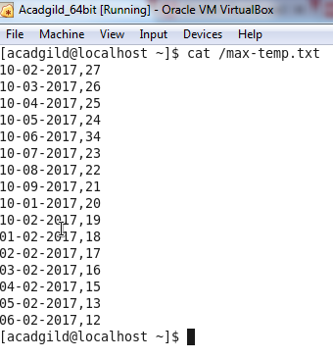

1. Who

The standard **Linux command** who displays a list of users who are currently logged into the computer. The who **command** is related to the **command** w, which provides the same information but also displays additional data and statistics.

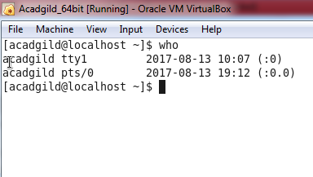

10.cd

**cd command in Linux**/Unix. **cd** is a **Linux command** to change the directory/folder of the terminal's shell.

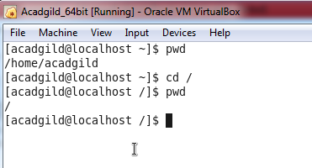

11.date

Date command is helpful to display date in several formats. It also allows you to set systems date and time.

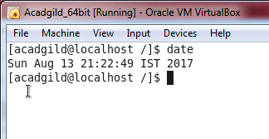

12.cal

Listed below are the traditional syntax and options for Unix **cal**. In general, if no options are given, **cal**displays the current month at the **command** line. It's a quick and convenient way to glance at the dates of the month, and can be useful as part of a login script.

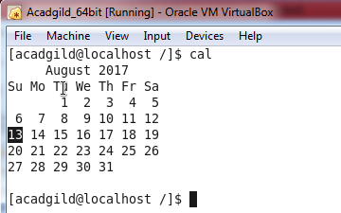

13.mv

 The **mv command** is used to move or rename files. Description. **mv** renames file SOURCE to DEST, or moves the SOURCE file (or files) to DIRECTORY. **mv** syntax.

14.cp

**Linux** “**cp**” **command**, options and its usage with **examples**. “**cp**” **command** is used to copy files and directories. This post describes “**cp**”**command** used in **Linux** along with usage **examples** and/or output. To copy files and directories use the **cp command** under **Linux**, **UNIX**, and BSD like operating systems

15.which

**Linux which Command**. **Which command** is very small and simple **command** to locate executables in the system. It allows user to pass several **command** names as arguments to get their paths in the system. “which” **commands** searches the path of executable in system paths set in $PATH environment variable.

